Brokers Risks’ Claims Portal Login Web Page 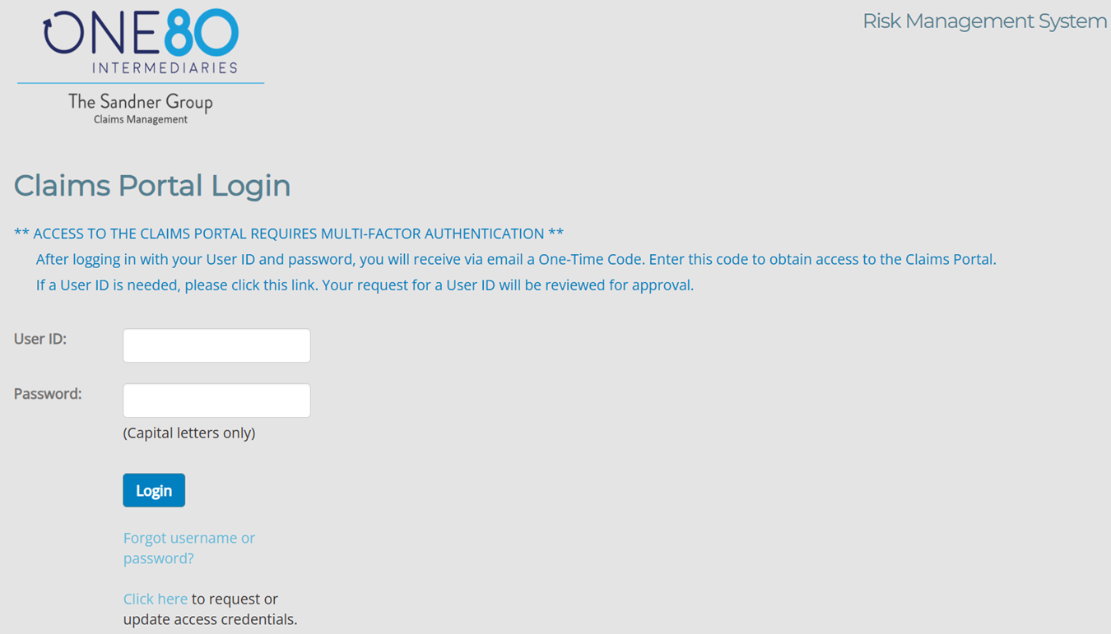
Multi-Factor Authentication Enhancement
After logging in with your User ID and password, a New Multi-Factor Authentication Web Page will be Displayed

Multi-Factor Authentication Web Page
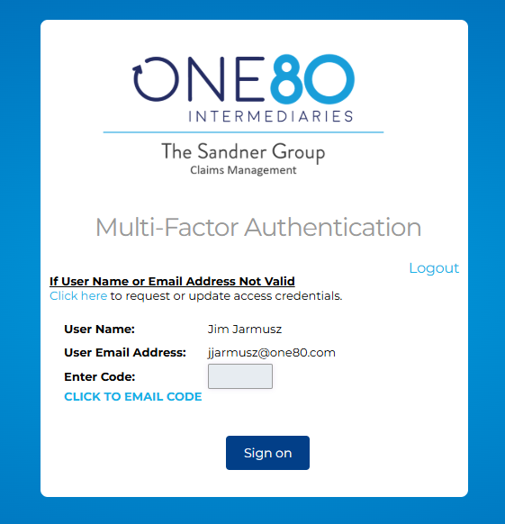
- CLICK TO EMAIL CODE (A 6-digit Code will be sent to the User’s Email Address)
- The Code will expire in 10 Minutes
- Enter 6 digit code and click Sign on submission button. If successful, access is allowed to report or inquire on claims.

If Username or Email Address is not correct, A new User Profile will need to be created
Click here to request or update access credentials (New User Request Form Web Page)
New User Request Form Web Page
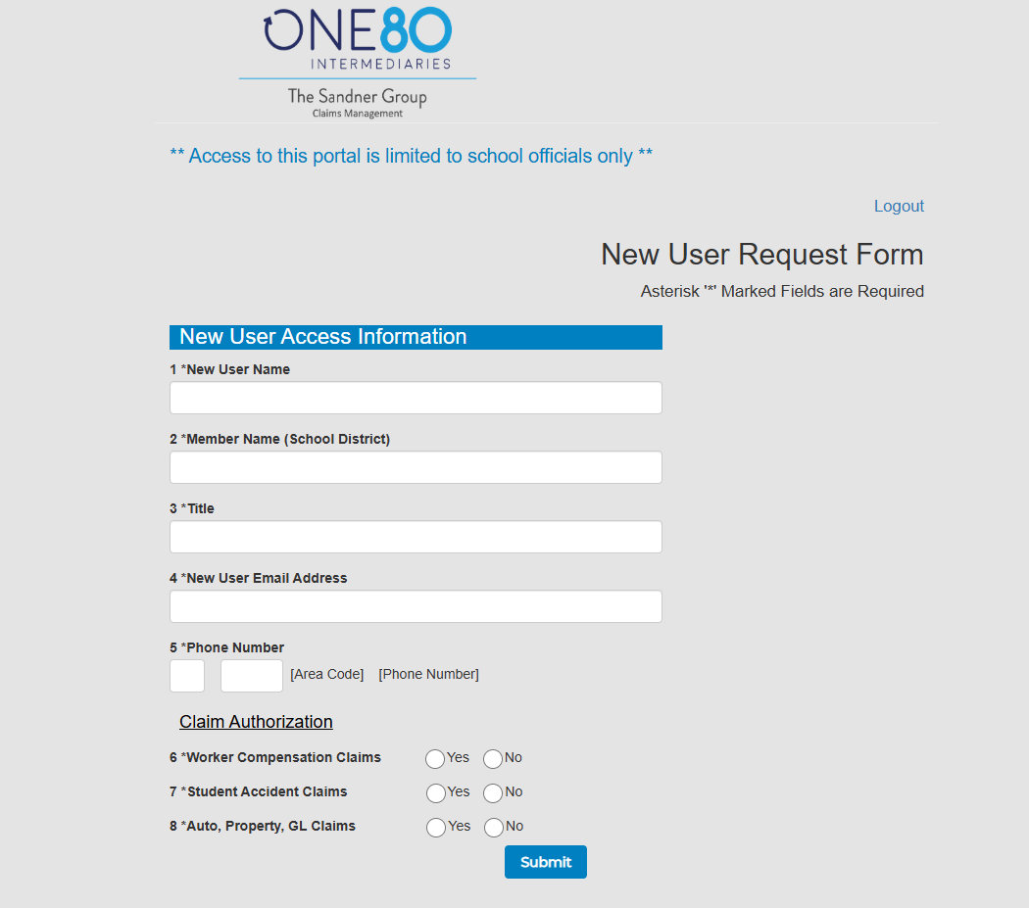
- Fill out the Form and a New User Profile will be created. The credentials will be emailed to the New User Email Address.

Brokers Risks’ Claims Portal Login Web Page- All Digit User Profiles are being Eliminated
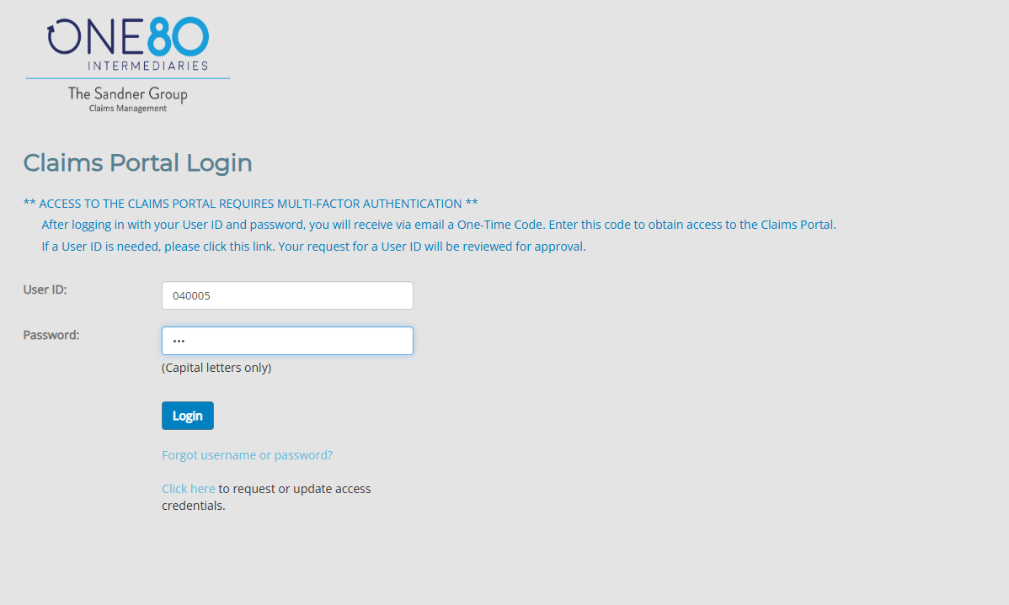
- If the User Profile encompasses all digits after logging in with your User ID and Password
- The New User Request Form Page will be Displayed

New User Request Form Web Page - All Digit User Profiles are being Eliminated
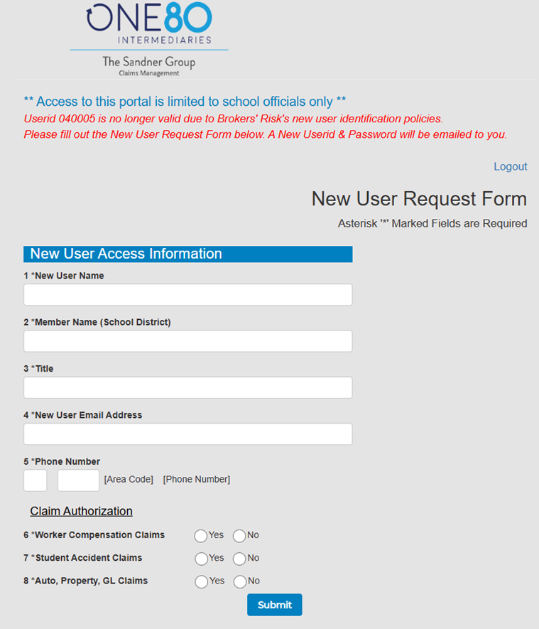
- Fill out the Form and a New Personalized User Profile will be created.
The credentials will be emailed to the New User Email Address.

